GIT Interview Questions------------ https://www.javatpoint.com/git-diff
Definition - Git is a free and open source distributed version control and source code management system designed to handle everything from small to very large projects with speed and efficiency.

Version Control System
Version Control System (VCS) is a software that helps software developers to work together and maintain a complete history of their work.
- Listed below are the functions of a VCS −
Allows developers to work simultaneously.
Does not allow overwriting each other’s changes.
Maintains a history of every version.
- Following are the types of VCS −
Centralized version control system (CVCS).
Distributed/Decentralized version control system (DVCS).

Centralized Version Control System
Centralized version control system (CVCS) uses a central server to store all files and enables team collaboration. But the major drawback of CVCS is its single point of failure, i.e., failure of the central server. Unfortunately, if the central server goes down for an hour, then during that hour, no one can collaborate at all. And even in a worst case, if the disk of the central server gets corrupted and proper backup has not been taken, then you will lose the entire history of the project. Here, distributed version control system (DVCS) comes into picture.

Distributed Version Control System
DVCS clients not only check out the latest snapshot of the directory but they also fully mirror the repository. If the server goes down, then the repository from any client can be copied back to the server to restore it. Every checkout is a full backup of the repository. Git does not rely on the central server and that is why you can perform many operations when you are offline. You can commit changes, create branches, view logs, and perform other operations when you are offline. You require network connection only to publish your changes and take the latest changes.

Advantages of Git

a) Free and open source

b) Fast and small

c) Implicit backup

d) Security

e) No need of powerful hardware

f) Easier branching

DVCS Terminologies

Local Repository
Every VCS tool provides a private workplace as a working copy. Developers make changes in their private workplace and after commit, these changes become a part of the repository. Git takes it one step further by providing them a private copy of the whole repository. Users can perform many operations with this repository such as add file, remove file, rename file, move file, commit changes, and many more.

Working Directory and Staging Area or Index
The working directory is the place where files are checked out. In other CVCS, developers generally make modifications and commit their changes directly to the repository. But Git uses a different strategy. Git doesn’t track each and every modified file. Whenever you do commit an operation, Git looks for the files present in the staging area. Only those files present in the staging area are considered for commit and not all the modified files.
Let us see the basic workflow of Git.
Step 1 − You modify a file from the working directory.
Step 2 − You add these files to the staging area.
Step 3 − You perform commit operation that moves the files from the staging area. After push operation, it stores the changes permanently to the Git repository.
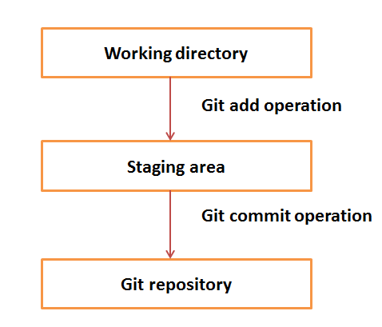
Suppose you modified two files, namely “sort.c” and “search.c” and you want two different commits for each operation. You can add one file in the staging area and do commit. After the first commit, repeat the same procedure for another file.
# add all untracked file
$ git add .

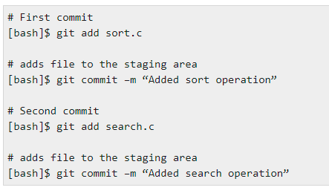

Blobs
Blob stands for Binary Large Object. Each version of a file is represented by blob. A blob holds the file data but doesn’t contain any metadata about the file. It is a binary file, and in Git database, it is named as SHA1 hash of that file. In Git, files are not addressed by names. Everything is content-addressed.

Trees
Tree is an object, which represents a directory. It holds blobs as well as other sub-directories. A tree is a binary file that stores references to blobs and trees which are also named as SHA1 hash of the tree object.

Commits
Commit holds the current state of the repository. A commit is also named by SHA1 hash. You can consider a commit object as a node of the linked list. Every commit object has a pointer to the parent commit object. From a given commit, you can traverse back by looking at the parent pointer to view the history of the commit. If a commit has multiple parent commits, then that particular commit has been created by merging two branches.

Branches
Branches are used to create another line of development. By default, Git has a master branch, which is same as trunk in Subversion. Usually, a branch is created to work on a new feature. Once the feature is completed, it is merged back with the master branch and we delete the branch. Every branch is referenced by HEAD, which points to the latest commit in the branch. Whenever you make a commit, HEAD is updated with the latest commit.

Tags
Tag assigns a meaningful name with a specific version in the repository. Tags are very similar to branches, but the difference is that tags are immutable. It means, tag is a branch, which nobody intends to modify. Once a tag is created for a particular commit, even if you create a new commit, it will not be updated. Usually, developers create tags for product releases.

Clone
Clone operation creates the instance of the repository. Clone operation not only checks out the working copy, but it also mirrors the complete repository. Users can perform many operations with this local repository. The only time networking gets involved is when the repository instances are being synchronized.

Pull
Pull operation copies the changes from a remote repository instance to a local one. The pull operation is used for synchronization between two repository instances. This is same as the update operation in Subversion.

Push
Push operation copies changes from a local repository instance to a remote one. This is used to store the changes permanently into the Git repository. This is same as the commit operation in Subversion.

HEAD
HEAD is a pointer, which always points to the latest commit in the branch. Whenever you make a commit, HEAD is updated with the latest commit. The heads of the branches are stored in .git/refs/heads/ directory.
[CentOS]$ ls -1 .git/refs/heads/
master

[CentOS]$ cat .git/refs/heads/master
570837e7d58fa4bccd86cb575d884502188b0c49

Revision
Revision represents the version of the source code. Revisions in Git are represented by commits. These commits are identified by SHA1 secure hashes.

URL
URL represents the location of the Git repository. Git URL is stored in config file.

Git - Life Cycle

General workflow is as follows −
- You clone the Git repository as a working copy.
- You modify the working copy by adding/editing files.
- If necessary, you also update the working copy by taking other developer's changes.
- You review the changes before commit.
- You commit changes. If everything is fine, then you push the changes to the repository.
- After committing, if you realize something is wrong, then you correct the last commit and push the changes to the repository.
Shown below is the pictorial representation of the work-flow.
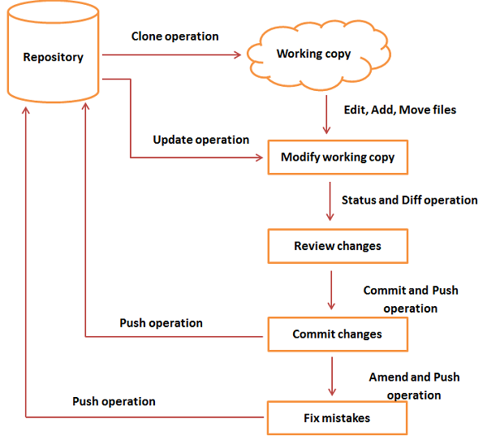

$git init :- This command will create a new and empty Git repository in the current working directory. It doesn't matter if other files in this directory existed or not; the command only creates the .git repository folder.
$ git add . :- Add all files to the staging area (= tell Git to include them in the next commit)
$ git commit -m "First commit" :- Wrap these changes in a commit and save them to the local Git repository
$ git status :- Displays paths that have differences between the index file and the current HEAD commit, paths that have differences between the working tree and the index file, and paths in the working tree that are not tracked by Git (and are not ignored by gitignore[5]).
$ .gitignore file :- In Git, you can use the gitignore file to specify untracked files that Git should ignore.
$ git log :- By default, with no arguments, git log lists the commits made in that repository in reverse chronological order; that is, the most recent commits show up first. As you can see, this command lists each commit with its SHA-1 checksum, the author’s name and email, the date written, and the commit message.

A huge number and variety of options to the git log command are available to show you exactly what you’re looking for. Here, we’ll show you some of the most popular.

One of the more helpful options is -p or --patch, which shows the difference (the patch output) introduced in each commit. You can also limit the number of log entries displayed, such as using -2 to show only the last two entries.

$ git log -p -2

$ git clone :- Cloning an Existing Repository
If you want to get a copy of an existing Git repository — for example, a project you’d like to contribute to — the command you need is git clone. If you’re familiar with other VCSs such as Subversion, you’ll notice that the command is "clone" and not "checkout". This is an important distinction — instead of getting just a working copy, Git receives a full copy of nearly all data that the server has. Every version of every file for the history of the project is pulled down by default when you run git clone. In fact, if your server disk gets corrupted, you can often use nearly any of the clones on any client to set the server back to the state it was in when it was cloned (you may lose some server-side hooks and such, but all the versioned data would be there — see Getting Git on a Server for more details).

You clone a repository with git clone <url>. For example, if you want to clone the Git linkable library called libgit2, you can do so like this:

$ git clone https://github.com/libgit2/libgit2

That creates a directory named libgit2, initializes a .git directory inside it, pulls down all the data for that repository, and checks out a working copy of the latest version. If you go into the new libgit2 directory that was just created, you’ll see the project files in there, ready to be worked on or used.

If you want to clone the repository into a directory named something other than libgit2, you can specify the new directory name as an additional argument:

$ git clone https://github.com/libgit2/libgit2 mylibgit

$ git show commmitId:- This command shows the metadata and content changes of the specified commit.
$ git diff :- Usage: git diff This command shows the file differences which are not yet staged. The usual use of git diff command that we can track the changes that have not been staged.
Suppose we have edited the newfile1.txt file. Now, we want to track what changes are not staged yet. Then we can do so from the git diff command. Consider the below output:
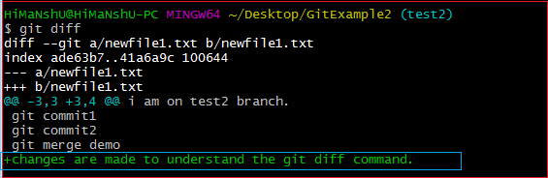
$ git diff –staged :- This command shows the differences between the files in the staging area and the latest version present. Track the changes that have staged but not committed
Now, the file is added to the staging area, but it is not committed yet. So, we can track the changes in the staging area also. To check the staged changes,
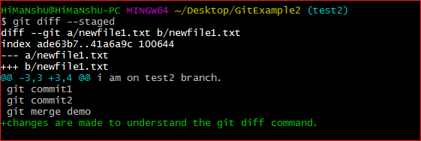

$ git diff HEAD :- , let us track the changes after committing a file. Suppose we have committed a file for the repository and made some additional changes after the commit. So we can track the file on this stage also.
In the below output, we have committed the changes that we made on our newfile1.txt. Consider the below output:
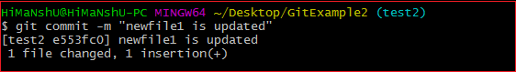
Now, we have changed the newfile.txt file again as "Changes are made after committing the file." To track the changes of this file, run the git diff command with HEAD argument.
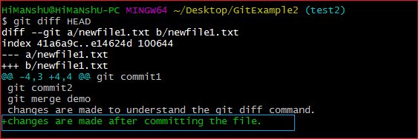

$ git diff <commit1-sha> <commit2-sha> :- command will display the changes between two commits. 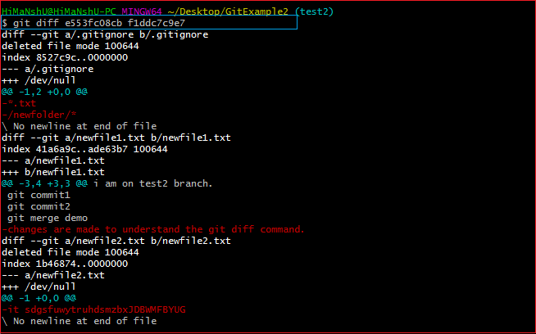
$ git diff [first branch] [second branch] :- This command shows the differences between the two branches mentioned. The above command will display the differences between branch 1 and branch 2. So that you can decide whether you want to merge the branch or not. Consider the below output:
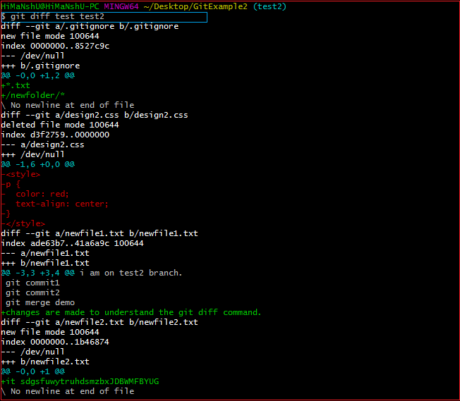
$git stash :- Sometimes you want to switch the branches, but you are working on an incomplete part of your current project. You don't want to make a commit of half-done work. Git stashing allows you to do so. The git stash command enables you to switch branches without committing the current branch.
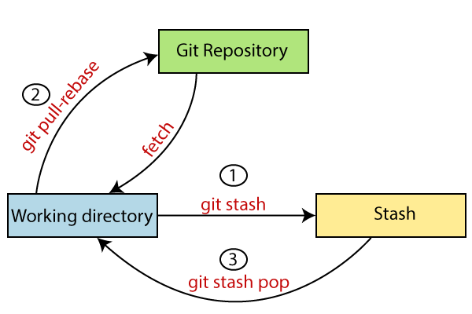
Generally, the stash's meaning is "store something safely in a hidden place." The sense in Git is also the same for stash; Git temporarily saves your data safely without committing.

Stashing takes the messy state of your working directory, and temporarily save it for further use. Many options are available with git stash. Some useful options are given below:
Git stash ,Git stash save , Git stash list ,Git stash apply ,Git stash changes ,Git stash pop ,Git stash drop ,Git stash clear ,Git stash branch
https://www.javatpoint.com/git-stash

$git fork :- A fork is a rough copy of a repository. Forking a repository allows you to freely test and debug with changes without affecting the original project. One of the excessive use of forking is to propose changes for bug fixing. To resolve an issue for a bug that you found, you can:
Fork the repository. ,Make the fix. ,Forward a pull request to the project owner.

Fork vs. Clone
Sometimes people considered the fork as clone command because of their property. Both commands are used to create another copy of the repository. But the significant difference is that the fork is used to create a server-side copy, and clone is used to create a local copy of the repository.
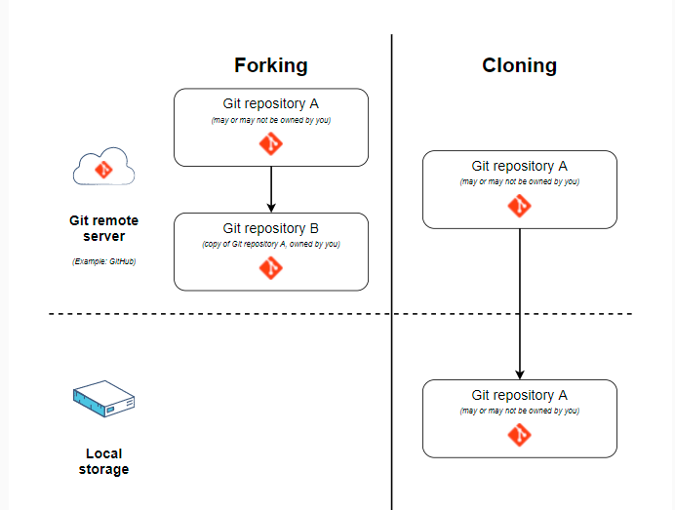
There is no particular command for forking the repository; instead, it is a service provided by third-party Git service like GitHub. Comparatively, git clone is a command-line utility that is used to create a local copy of the project.

Generally, people working on the same project clone the repository and the external contributors fork the repository.
https://www.javatpoint.com/git-fork

$ git index :- The Git index is a staging area between the working directory and repository. It is used to build up a set of changes that you want to commit together. To better understand the Git index, then first understand the working directory and repository.
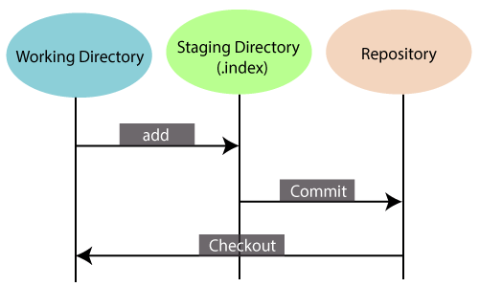
Git Index
There are three places in Git where file changes can reside, and these are working directory, staging area, and the repository. To better understand the Git index first, let's take a quick view of these places.

Working directory:
When you worked on your project and made some changes, you are dealing with your project's working directory. This project directory is available on your computer's filesystem. All the changes you make will remain in the working directory until you add them to the staging area.

Staging area:
The staging area can be described as a preview of your next commit. When you create a git commit, Git takes changes that are in the staging area and make them as a new commit. You are allowed to add and remove changes from the staging area. The staging area can be considered as a real area where git stores the changes.

Although, Git doesn't have a dedicated staging directory where it can store some objects representing file changes (blobs). Instead of this, it uses a file called index.

Repository:
In Git, Repository is like a data structure used by GIt to store metadata for a set of files and directories. It contains the collection of the files as well as the history of changes made to those files. Repositories in Git is considered as your project folder. A repository has all the project-related data. Distinct projects have distinct repositories.

You can check what is in the index by the git status command. The git status command allows you to see which files are staged, modified but not yet staged, and completely untracked. Staged files mean, it is currently in the index. See the below example.
https://www.javatpoint.com/git-index
$ git checkout :- In Git, the term checkout is used for the act of switching between different versions of a target entity. The git checkout command is used to switch between branches in a repository. Be careful with your staged files and commits when switching between branches.

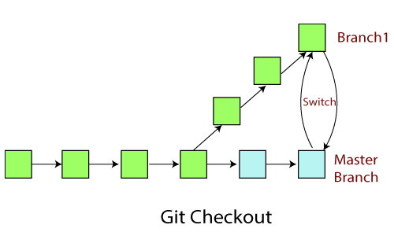
The git checkout command operates upon three different entities which are files, commits, and branches. Sometimes this command can be dangerous because there is no undo option available on this command.

It checks the branches and updates the files in the working directory to match the version already available in that branch, and it forwards the updates to Git to save all new commit in that branch.

Operations on Git Checkout
We can perform many operations by git checkout command like the switch to a specific branch, create a new branch, checkout a remote branch, and more. The git branch and git checkout commands can be integrated.

Checkout Branch
You can demonstrate how to view a list of available branches by executing the git branch command and switch to a specified branch.
To demonstrate available branches in repository, use the below command:
$ git branch
Now, you have the list of available branches. To switch between branches, use the below command.
Syntax:
$ git checkout <branchname>

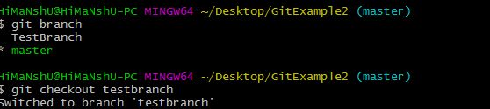
As you can see in the given output that master branch has switched to TestBranch.

Create and Switch Branch
The git checkout commands let you create and switch to a new branch. You can not only create a new branch but also switch it simultaneously by a single command. The git checkout -b option is a convenience flag that performs run git branch <new-branch>operation before running git checkout <new-branch>.
Syntax:
$ git checkout -b <branchname>
Output:
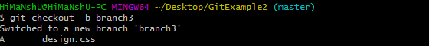

As you can see in the given output, branch3 is created and switched from the master branch.

Checkout Remote Branch
Git allows you to check out a remote branch by git checkout command. It is a way for a programmer to access the work of a colleague or collaborator for review and collaboration. Each remote repository contains its own set of branches. So, to check out a remote branch, you have first to fetch the contents of the branch.

$ git fetch --all
In the latest versions of Git, you can check out the remote branch like a local branch.

Syntax:
$ git checkout <remotebranch>
Output:
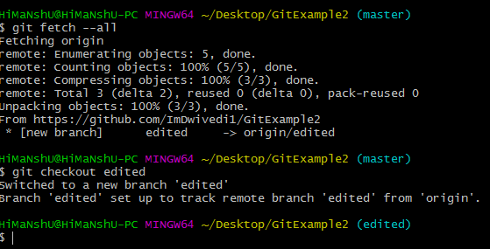
In the above output, first, the fetch command is executed to fetch the remote data; after that, the checkout command is executed to check out a remote branch.

Edited is my remote branch. Here, we have switched to edited branch from master branch by git command line.

The earlier versions of Git require the creation of a new branch based on the remote. In earlier versions, below command is used to check out the remote branch.

$ git checkout <remotebranch> origin/<remotebranch>
---------------------------
$ git revert :- the term revert is used to revert some changes. The git revert command is used to apply revert operation. It is an undo type command. However, it is not a traditional undo alternative. It does not delete any data in this process; instead, it will create a new change with the opposite effect and thereby undo the specified commit. Generally, git revert is a commit.
It can be useful for tracking bugs in the project. If you want to remove something from history then git revert is a wrong choice.

Moreover, we can say that git revert records some new changes that are just opposite to previously made commits.

$ git revert <commit-ish> :- The commit option is used to revert a commit. To revert a commit, we need the commit reference id. The git log command can access it.
$ git revert -e <commit-ish> :- It is used to edit the commit message before reverting the commit. It is a default option in git revert command.

-m parent-number /--mainline parent-number: it is used to revert the merging. Generally, we cannot revert a merge because we do not know which side of the merge should be considered as the mainline. We can specify the parent number and allows revert to reverse the change relative to the specified parent.
-n/--no edit: This option will not open a text editor. It will directly revert the last commit.
$ git revert -n <commit-ish>
--cleanup=<mode>: The cleanup option determines how to strip spaces and comments from the message.

-n/--no-commit: Generally, the revert command commits by default. The no-commit option will not automatically commit. In addition, if this option is used, your index does not have to match the HEAD commit.
The no-commit option is beneficial for reverting more than one commits effect to your index in a row.
https://www.javatpoint.com/git-revert

$ git reset :- The term reset stands for undoing changes. The git reset command is used to reset the changes. The git reset command has three core forms of invocation. These forms are as follows.
Soft ,Mixed ,Hard
Git uses an index (staging area), HEAD, and working directory for creating and reverting commits.
$ git reset –hard :- It will first move the Head and update the index with the contents of the commits. It is the most direct, unsafe, and frequently used option. The --hard option changes the Commit History, and ref pointers are updated to the specified commit. Then, the Staging Index and Working Directory need to reset to match that of the specified commit. Any previously pending commits to the Staging Index and the Working Directory gets reset to match Commit Tree. It means any awaiting work will be lost.

Let's understand the --hard option with an example. Suppose I have added a new file to my existing repository. To add a new file to the repository, run the below command:
- $ git add <file name>
To check the status of the repository, run the below command:
- $ git status
To check the status of the Head and previous commits, run the below command:
- $ git log
Consider the below image:
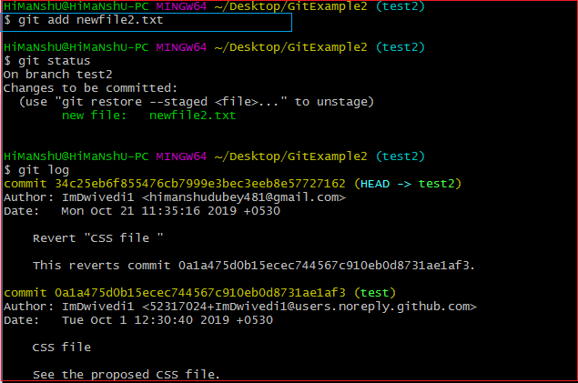
In the above output, I have added a file named newfile2.txt. I have checked the status of the repository. We can see that the current head position yet not changed because I have not committed the changes. Now, I am going to perform the reset --hard option. The git reset hard command will be performed as:
- $ git reset --hard
Consider the below output:
As you can see in the above output, the -hard option is operated on the available repository. This option will reset the changes and match the position of the Head before the last changes. It will remove the available changes from the staging area. Consider the below output:
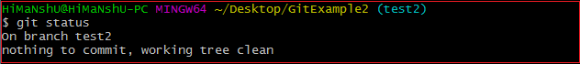
The above output is displaying the status of the repository after the hard reset. We can see there is nothing to commit in my repository because all the changes removed by the reset hard option to match the status of the current Head with the previous one. So the file newfile2.txt has been removed from the repository.

Generally, the reset hard mode performs below operations:
- It will move the HEAD pointer.
- It will update the staging Area with the content that the HEAD is pointing.
- It will update the working directory to match the Staging Area.

$ git reset --mixed :- A mixed option is a default option of the git reset command. If we would not pass any argument, then the git reset command considered as --mixed as default option. A mixed option updates the ref pointers. The staging area also reset to the state of a specified commit. The undone changes transferred to the working directory. Let's understand it with an example.
Let's create a new file say newfile2.txt. Check the status of the repository. To check the status of the repository, run the below command: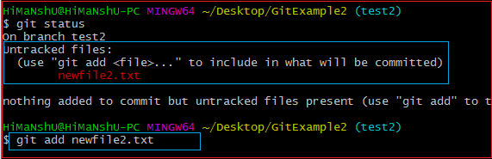
In the above output, I have added a newfile2.txt to my local repository. Now, we will perform the reset mixed command on this repository. It will operate as:
- $ git reset --mixed
Or we can use only git reset command instead of this command.
- $ git reset
The above command will reset the status of the Head, and it will not delete any data from the staging area to match the position of the Head. Consider the below output:
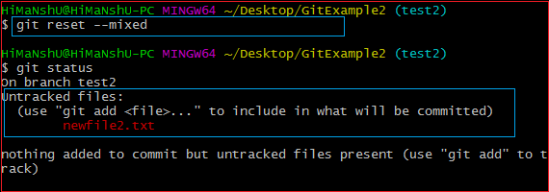
From the above output, we can see that we have reset the position of the Head by performing the git reset -mixed command. Also, we have checked the status of the repository. As we can see that the status of the repository has not been changed by this command. So it is clear that the mixed-mode does not clear any data from the staging area.
Generally, the reset mixed mode performs the below operations:
- It will move the HEAD pointer
- It will update the Staging Area with the content that the HEAD is pointing to.
It will not update the working directory as git hard mode does. It will only reset the index but not the working tree, then it generates the report of the files which have not been updated.
If -N is specified on the command line, then the statements will be considered as intent-to-add by Git.

$ git reset—soft :- The soft option does not touch the index file or working tree at all, but it resets the Head as all options do. When the soft mode runs, the refs pointers updated, and the resets stop there. It will act as git amend command. It is not an authoritative command. Sometimes developers considered it as a waste of time.

Generally, it is used to change the position of the Head. Let's understand how it will change the position of the Head.
I have made changes in my file newfile2.txt and commit it. So, the current position of Head is shifted on the latest commit. To check the status of Head, run the below command:
$ git log
Consider the below output:
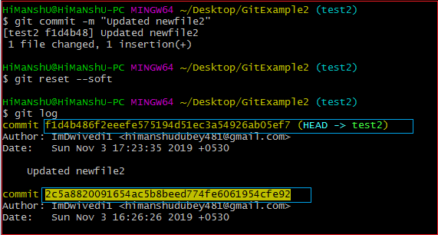

From the above output, you can see that the current position of the HEAD is on f1d4b486f2eeefe575194d51ec3a54926ab05ef7 commit. But, I want to switch it on my older commit 2c5a8820091654ac5b8beed774fe6061954cfe92. Since the commit-sha number is a unique number that is provided by sha algorithm. To switch the HEAD, run the below command:
- $ git reset --soft 2c5a8820091654
The above command will shift my HEAD to a particular commit. Consider the below output:
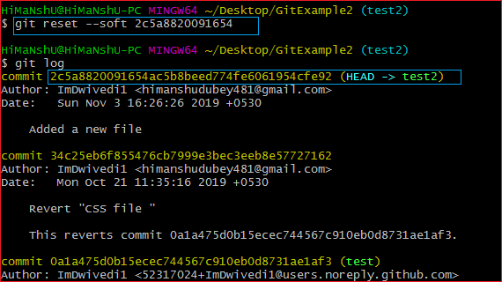
As you can see from the above output, the HEAD has been shifted to a particular commit by git reset --soft mode.
Git Reset to Commit
Sometimes we need to reset a particular commit; Git allows us to do so. We can reset to a particular commit. To reset it, git reset command can be used with any option supported by reset command. It will take the default behavior of a particular command and reset the given commit. The syntax for resetting commit is given below:
- $ git reset <option> <commit-sha>

$ git rm <file Name> :- In Git, the term rm stands for remove. It is used to remove individual files or a collection of files. The key function of git rm is to remove tracked files from the Git index. Additionally, it can be used to remove files from both the working directory and staging index.

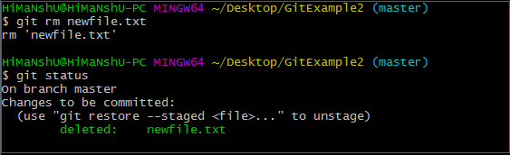
In the above output, the file newfile.txt has been removed from the version control system. So the repository and the status are shown as deleted. If we use only the rm command, then it will not permanently delete the file from the Git. It can be tracked in the staging area. Consider the below output:
In the above output, the file newfile2.txt has been deleted. But when we check the status of the repository, we can track the file in the staging area. It means the newfile2 yet not deleted from the staging area, and it is also available in the repository. We can get it back on the version control system by committing it. To commit the file, first, add it to the index and then commit it. To add this file in the index, run the below command:
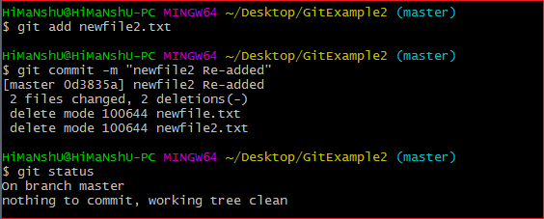
In the above output, we are retrieving the file from the staging area to our directory. The newfile2.txt is re-added to our repository.
$ git rm --cached <file name> :- Sometimes you want to remove files from the Git but keep the files in your local repository. In other words, you do not want to share your file on Git. Git allows you to do so. The cached option is used in this case. It specifies that the removal operation will only act on the staging index, not on the repository

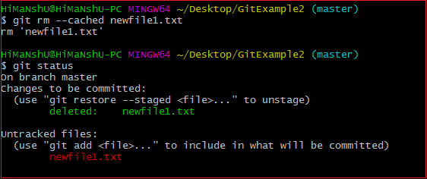
As we can see from the above output, the newfile1.txt file is deleted from the version control system, but it can be tracked in the repository. This file is available on the version control system as an untracked file. We can track it by committing it.
Undo the Git Rm Command
Execution of git rm command is not permanent; it can be reverted after execution. These changes cannot be persisted until a new commit is made on the repository. We can undo the git rm command. There are several ways to do so. The most usual and straight-forward way is git reset command. The git reset command will be used as follows:
- $ git reset HEAD
Or we can also use:
- $ git reset --hard
The above command will reset the position of the head. So that it will get the position of its just previous point. Consider the below output:

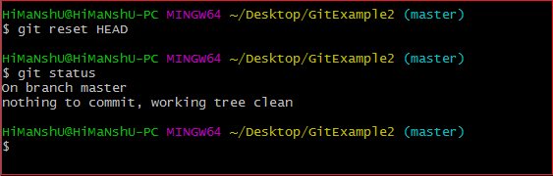
From the above output, we can see that the file has been successfully reset to its previous position.

There is another way to undo the git rm command. We can also do it by git checkout command. A checkout has the same effect and restores the latest version of a file from HEAD. It will be used as follows: $ git checkout.
https://www.javatpoint.com/git-rm

$ git cherry-pick <commit id> :- Cherry-picking in Git stands for applying some commit from one branch into another branch. In case you made a mistake and committed a change into the wrong branch, but do not want to merge the whole branch. You can revert the commit and apply it on another branch.
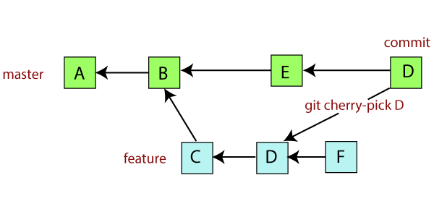
Suppose you are working with a team of developers on a medium to large-sized project. Some changes proposed by another team member and you want to apply some of them to your main project, not all. Since managing the changes between several Git branches can become a complex task, and you don't want to merge a whole branch into another branch. You only need to pick one or two specific commits. To pick some changes into your main project branch from other branches is called cherry-picking.

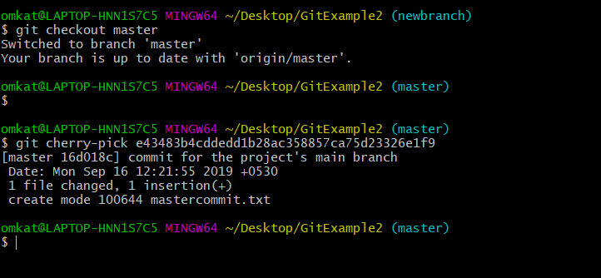

https://www.javatpoint.com/git-cherry-pick

$ git branch <branch name> :- A branch is a version of the repository that diverges from the main working project. It is a feature available in most modern version control systems. A Git project can have more than one branch. These branches are a pointer to a snapshot of your changes. When you want to add a new feature or fix a bug, you spawn a new branch to summarize your changes. So, it is complex to merge the unstable code with the main code base and also facilitates you to clean up your future history before merging with the main branch.

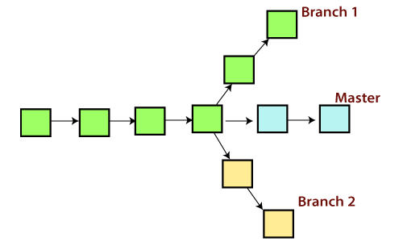
Git Master Branch
The master branch is a default branch in Git. It is instantiated when first commit made on the project. When you make the first commit, you're given a master branch to the starting commit point. When you start making a commit, then master branch pointer automatically moves forward. A repository can have only one master branch.
Master branch is the branch in which all the changes eventually get merged back. It can be called as an official working version of your project.
Operations on Branches
We can perform various operations on Git branches. The git branch command allows you to create, list, rename and delete branches. Many operations on branches are applied by git checkout and git merge command. So, the git branch is tightly integrated with the git checkout and git merge commands.

This command will create the branch B1 locally in Git directory.

List Branch
You can List all of the available branches in your repository by using the following command.
Either we can use git branch - list or git branch command to list the available branches in the repository.
Syntax:
- $ git branch --list
or
- $ git branch
Output:
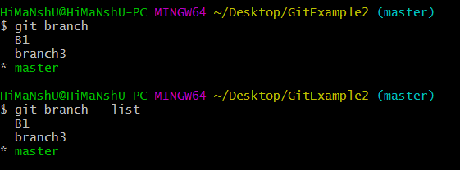
Here, both commands are listing the available branches in the repository. The symbol * is representing currently active branch.
$ git branch -d<branch name>:-You can delete the specified branch. It is a safe operation. In this command, Git prevents you from deleting the branch if it has unmerged changes.
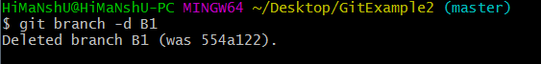

$ git push origin -delete <branch name> :- You can delete a remote branch from Git desktop application. Below command is used to delete a remote branch:

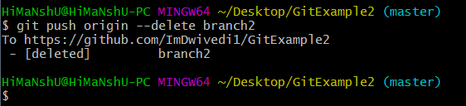

$ git checkout<branch name> :- Git allows you to switch between the branches without making a commit. You can switch between two branches with the git checkout command. To switch between the branches

$ git branch -m master :- You can switch to the master branch from any other branch

$ git branch -m <old branch name><new branch name> :- We can rename the branch with the help of the git branch command.
$ git merge <branch name> :- Git allows you to merge the other branch with the currently active branch. You can merge two branches with the help of git merge command.

Git Merge and Merge Conflict :-
In Git, the merging is a procedure to connect the forked history. It joins two or more development history together. The git merge command facilitates you to take the data created by git branch and integrate them into a single branch. Git merge will associate a series of commits into one unified history. Generally, git merge is used to combine two branches.
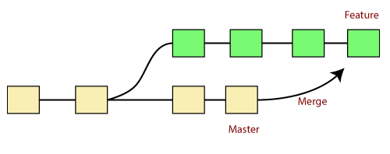
It is used to maintain distinct lines of development; at some stage, you want to merge the changes in one branch. It is essential to understand how merging works in Git.
In the above figure, there are two branches master and feature. We can see that we made some commits in both functionality and master branch, and merge them. It works as a pointer. It will find a common base commit between branches. Once Git finds a shared base commit, it will create a new "merge commit." It combines the changes of each queued merge commit sequence.
The "git merge" command
The git merge command is used to merge the branches.
The syntax for the git merge command is as:
- $ git merge <query>
It can be used in various context. Some are as follows:

$ git merge <commit> :- The above command will merge the specified commit to the currently active branch. You can also merge the specified commit to a specified branch by passing in the branch name in <commit>. Let's see how to commit to a currently active branch.
See the below example. I have made some changes in my project's file newfile1.txt and committed it in my test branch.
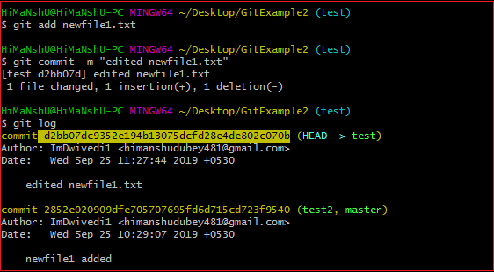
Copy the particular commit you want to merge on an active branch and perform the merge operation. See the below output:
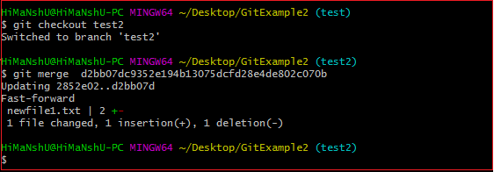

In the above output, we have merged the previous commit in the active branch test2.

Scenario2: To merge commits into the master branch:
To merge a specified commit into master, first discover its commit id. Use the log command to find the particular commit id.
- $git log
See the below output:
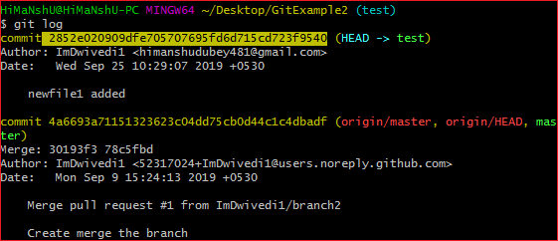
To merge the commits into the master branch, switch over to the master branch.
- $ git checkout master
Now, Switch to branch 'master' to perform merging operation on a commit. Use the git merge command along with master branch name. The syntax for this is as follows:
- $ git merge master
See the below output:
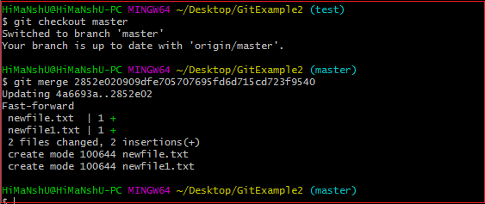
As shown in the above output, the commit for the commit id 2852e020909dfe705707695fd6d715cd723f9540 has merged into the master branch. Two files have changed in master branch. However, we have made this commit in the test branch. So, it is possible to merge any commit in any of the branches.

Open new files, and you will notice that the new line that we have committed to the test branch is now copied on the master branch.
Scenario 3: Git merge branch.
Git allows merging the whole branch in another branch. Suppose you have made many changes on a branch and want to merge all of that at a time. Git allows you to do so. See the below example:
In the given output, I have made changes in newfile1 on the test branch. Now, I have committed this change in the test branch.
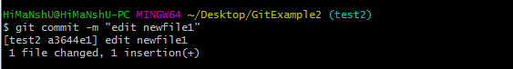
Now, switch to the desired branch you want to merge. In the given example, I have switched to the master branch. Perform the below command to merge the whole branch in the active branch.
- $ git merge <branchname>
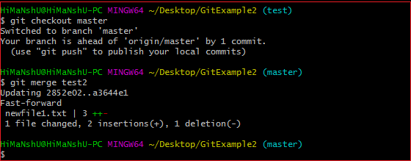
As you can see from the given output, the whole commits of branch test2 have merged to branch master.

Git Merge Conflict :
When two branches are trying to merge, and both are edited at the same time and in the same file, Git won't be able to identify which version is to take for changes. Such a situation is called merge conflict. If such a situation occurs, it stops just before the merge commit so that you can resolve the conflicts manually.
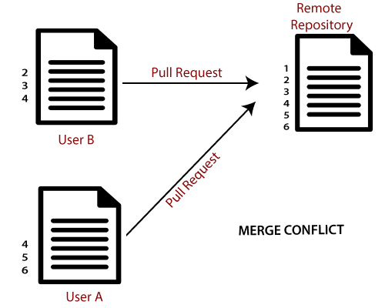
https://www.javatpoint.com/git-merge-and-merge-conflict

$ git rebase :- Rebasing is a process to reapply commits on top of another base trip. It is used to apply a sequence of commits from distinct branches into a final commit. It is an alternative of git merge command. It is a linear process of merging. In Git, the term rebase is referred to as the process of moving or combining a sequence of commits to a new base commit. Rebasing is very beneficial and it visualized the process in the environment of a feature branching workflow.

It is good to rebase your branch before merging it.
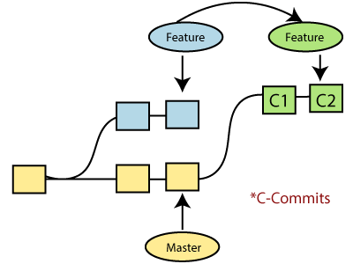
Generally, it is an alternative of git merge command. Merge is always a forward changing record. Comparatively, rebase is a compelling history rewriting tool in git. It merges the different commits one by one.

Suppose you have made three commits in your master branch and three in your other branch named test. If you merge this, then it will merge all commits in a time. But if you rebase it, then it will be merged in a linear manner. Consider the below image:
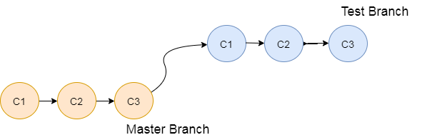
The above image describes how git rebase works. The three commits of the master branch are merged linearly with the commits of the test branch.

Merging is the most straightforward way to integrate the branches. It performs a three-way merge between the two latest branch commits.

How to Rebase
When you made some commits on a feature branch (test branch) and some in the master branch. You can rebase any of these branches. Use the git log command to track the changes (commit history). Checkout to the desired branch you want to rebase. Now perform the rebase command as follows:

Syntax:
$git rebase <branch name>
If there are some conflicts in the branch, resolve them, and perform below commands to continue changes:

$ git status
It is used to check the status,

$git rebase --continue
The above command is used to continue with the changes you made. If you want to skip the change, you can skip as follows:

$ git rebase --skip
When the rebasing is completed. Push the repository to the origin. Consider the below example to understand the git merge command.

Suppose that you have a branch say test2 on which you are working. You are now on the test2 branch and made some changes in the project's file newfile1.txt.

Add this file to repository:
$ git add newfile1.txt

Now, commit the changes. Use the below command:
$ git commit -m "new commit for test2 branch."

Now Switch the branch to master using below commands
$ git checkout master

Now you are on the master branch. I have added the changes to my file, says newfile.txt. The below command is used to add the file in the repository.

$ git add newfile.txt
Now commit the file for changes:

$ git commit -m " new commit made on the master branch."
Now To check the log history, perform the below command.
$ git log --oneline
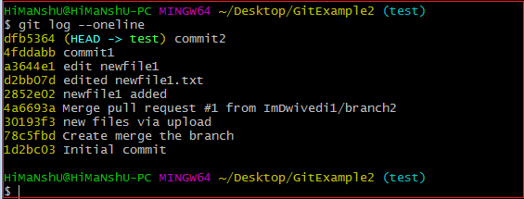
As we can see in the log history, there is a new commit in the master branch. If I want to rebase my test2 branch, what should I do? See the below rebase branch scenario:

Rebase Branch
If we have many commits from distinct branches and want to merge it in one. To do so, we have two choices either we can merge it or rebase it. It is good to rebase your branch.

From the above example, we have committed to the master branch and want to rebase it on the test2 branch. Let's see the below commands:

$ git checkout test2
This command will switch you on the test2 branch from the master.
Switched to branch 'test2.'
Now you are on the test2 branch. Hence, you can rebase the test2 branch with the master branch. See the below command:

$ git rebase master
This command will rebase the test2 branch and will show as Applying: new commit on test2 branch. Consider the below output:
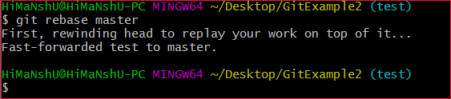
https://www.javatpoint.com/git-rebase

Git Squash:- In Git, the term squash is used to squash the previous commits into one. It is not a command; instead, it is a keyword. The squash is an excellent technique for group-specific changes before forwarding them to others. You can merge several commits into a single commit with the compelling interactive rebase command.
If you are a Git user, then you must have realized the importance of squashing a commit. Especially if you are an open-source contributor, then many times, you have to create a PR (pull request) with squashed commit. You can also squash commits if you have already created a PR.
Let's understand how to squash commits?
Git Squash Commits
Being a responsible contributor to Git, it is necessary to make the collaboration process efficient and meaningful. Git allows some powerful collaboration tools in different ways. Git squash is one of the powerful tools that facilitate efficient and less painful collaboration.

The squash is not any command; instead, it's one of many options available to you under git interactive rebases. The squash allows us to rewrite history. Suppose we have made many commits during the project work, squashing all the commits into a large commit is the right choice than pushing. Let's understand how to squash two commits.
Step1: Check the commit history
To check the commit history, run the below command:
$ git log --oneline
The given command will display the history in one line. We can track the history and choose the commits we want to squash. Consider the below output:
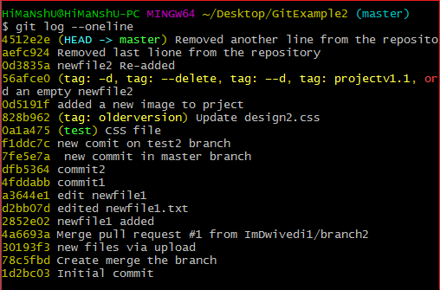

Step 2: Choose the commits to squash.
Suppose we want to squash the last commits. To squash commits, run the below command:
$ git rebase -i HEAD ~3
The above command will open your default text editor and will squash the last three commits. The editor will open as follows:
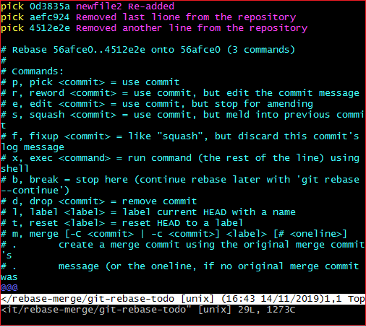
From the above image, we can see previous commits shown at the top of the editor. If we want to merge them into a single commit, then we have to replace the word pick with the squash on the top of the editor. To write on the editor, press 'i' button to enter in insert mode. After editing the document, press the :wq to save and exit from the editor.
Step 3: update the commits
On pressing enter key, a new window of the text editor will be opened to confirm the commit. We can edit the commit message on this screen.
I am editing my first commit message because it will be a combination of all three commits. Consider the below image:
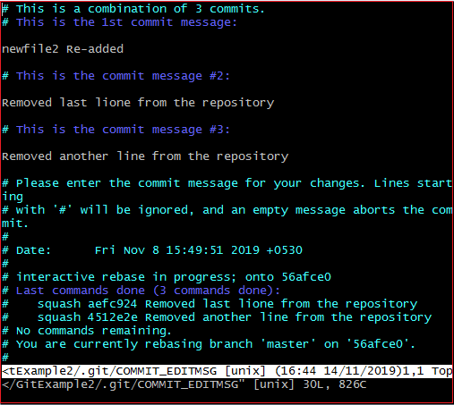
The above image is the editor screen to confirm the merging of commits. Here we can update the commit messages. To edit on this editor, press the 'i' button for insert mode and edit the desired text. Press the :wq keys, to save and exit from the editor.
When we exit the editor, it will show the description of updates. Consider the below output:
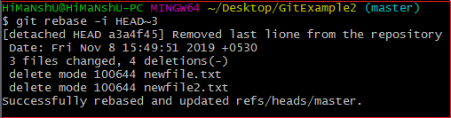
The above output is listing the description of changes that have been made on the repository. Now, the commits have been squashed. Check the commit history for confirmation with the help of the git log. Consider the below output:
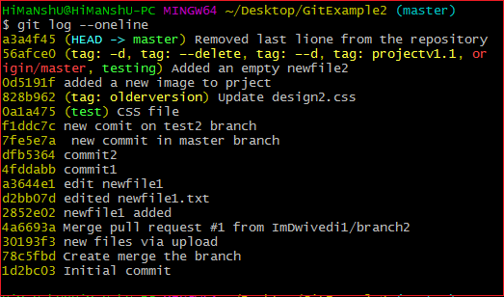
Step 4: Push the squashed commit
Now, we can push this squashed commit on the remote server. To push this squashed commit, run the below command:
$ git push origin master
Or
$ git push -f origin master
The above command will push the changes on the remote server. We can check this commit on our remote repository. Consider the below image:
https://www.javatpoint.com/git-squash
Git Fetch :-
Git "fetch" Downloads commits, objects and refs from another repository. It fetches branches and tags from one or more repositories. It holds repositories along with the objects that are necessary to complete their histories to keep updated remote-tracking branches.
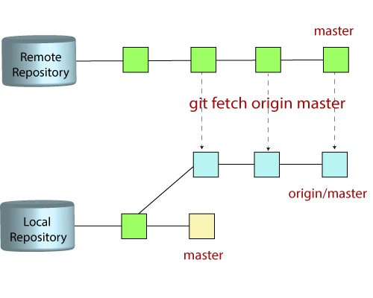
The "git fetch"command
The "git fetch" command is used to pull the updates from remote-tracking branches. Additionally, we can get the updates that have been pushed to our remote branches to our local machines. As we know, a branch is a variation of our repositories main code, so the remote-tracking branches are branches that have been set up to pull and push from remote repository.
How to fetch Git Repository
We can use fetch command with many arguments for a particular data fetch. See the below scenarios to understand the uses of fetch command.
Scenario 1: To fetch the remote repository:
We can fetch the complete repository with the help of fetch command from a repository URL like a pull command does. See the below output:
Syntax:
$ git fetch< repository Url>
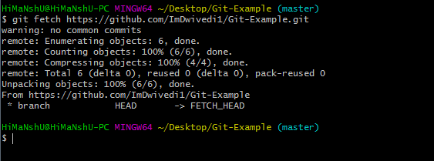
In the above output, the complete repository has fetched from a remote URL.
Scenario 2: To fetch a specific branch: We can fetch a specific branch from a repository. It will only access the element from a specific branch. See the below output:
$ git fetch <branch URL><branch name> 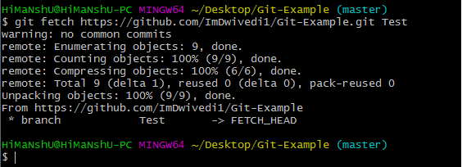In the given output, the specific branch test has fetched from a remote URL.
Scenario 3: To fetch all the branches simultaneously: The git fetch command allows to fetch all branches simultaneously from a remote repository. See the below example: $ git fetch -all 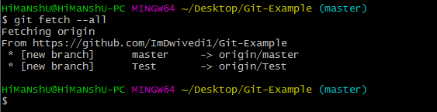In the above output, all the branches have fetched from the repository Git-Example.
Scenario 4: To synchronize the local repository: Suppose, your team member has added some new features to your remote repository. So, to add these updates to your local repository, use the git fetch command. It is used as follows. =>$ git fetch origin 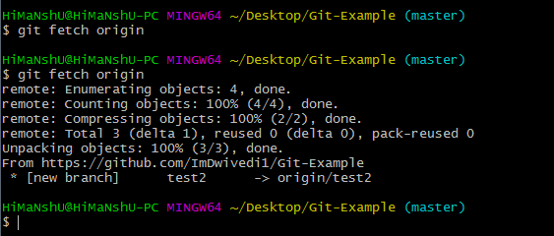In the above output, new features of the remote repository have updated to my local system. In this output, the branch test2 and its objects are added to the local repository.
The git fetch can fetch from either a single named repository or URL or from several repositories at once. It can be considered as the safe version of the git pull commands.
The git fetch downloads the remote content but not update your local repo's working state. When no remote server is specified, by default, it will fetch the origin remote.
Differences between git fetch and git pull
To understand the differences between fetch and pull, let's know the similarities between both of these commands. Both commands are used to download the data from a remote repository. But both of these commands work differently. Like when you do a git pull, it gets all the changes from the remote or central repository and makes it available to your corresponding branch in your local repository. When you do a git fetch, it fetches all the changes from the remote repository and stores it in a separate branch in your local repository. You can reflect those changes in your corresponding branches by merging.So basically,
git pull = git fetch + git merge
https://www.javatpoint.com/git-fetch
Git Pull / Pull Request
The term pull is used to receive data from GitHub. It fetches and merges changes from the remote server to your working directory. The git pull command is used to pull a repository.
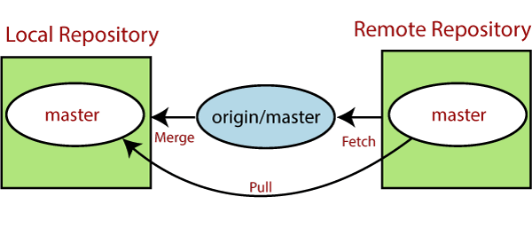
Pull request is a process for a developer to notify team members that they have completed a feature. Once their feature branch is ready, the developer files a pull request via their remote server account. Pull request announces all the team members that they need to review the code and merge it into the master branch.

The below figure demonstrates how pull acts between different locations and how it is similar or dissimilar to other related commands.
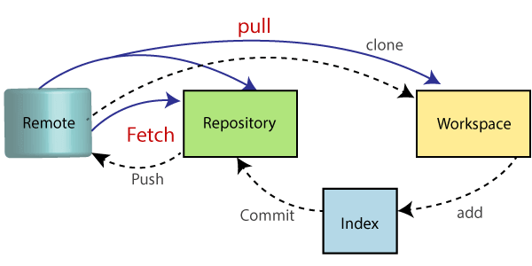
The "git pull" command
The pull command is used to access the changes (commits)from a remote repository to the local repository. It updates the local branches with the remote-tracking branches. Remote tracking branches are branches that have been set up to push and pull from the remote repository. Generally, it is a collection of the fetch and merges command. First, it fetches the changes from remote and combined them with the local repository.

The syntax of the git pull command is given below:
$ git pull <option> [<repository URL><refspec>...] :-
<option>: Options are the commands; these commands are used as an additional option in a particular command. Options can be -q (quiet), -v (verbose), -e(edit) and more.
<repository URL>: Repository URL is your remote repository's URL where you have stored your original repositories like GitHub or any other git service. This URL looks like: https://github.com/ImDwivedi1/GitExample2.git
<Refspec>: A ref is referred to commit, for example, head (branches), tags, and remote branches. You can check head, tags, and remote repository in .git/ref directory on your local repository. Refspec specifies and updates the refs.
https://www.javatpoint.com/git-pull
Git Push :-
The push term refers to upload local repository content to a remote repository. Pushing is an act of transfer commits from your local repository to a remote repository. Pushing is capable of overwriting changes; caution should be taken when pushing.
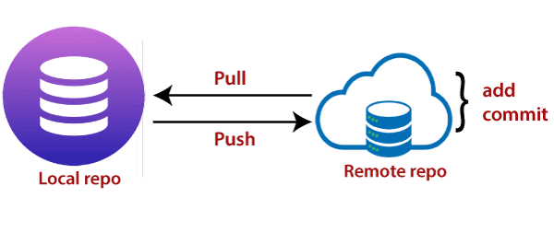
Moreover, we can say the push updates the remote refs with local refs. Every time you push into the repository, it is updated with some interesting changes that you made. If we do not specify the location of a repository, then it will push to default location at origin master.
The "git push" command is used to push into the repository. The push command can be considered as a tool to transfer commits between local and remote repositories. The basic syntax is given below:
$ git push <option> [<Remote URL><branch name><refspec>...]
Push command supports many additional options. Some options are as follows under push tags.
Git Push Tags
<repository>: The repository is the destination of a push operation. It can be either a URL or the name of a remote repository.
<refspec>: It specifies the destination ref to update source object.
--all: The word "all" stands for all branches. It pushes all branches.
--prune: It removes the remote branches that do not have a local counterpart. Means, if you have a remote branch say demo, if this branch does not exist locally, then it will be removed.
--mirror: It is used to mirror the repository to the remote. Updated or Newly created local refs will be pushed to the remote end. It can be force updated on the remote end. The deleted refs will be removed from the remote end.
--dry-run: Dry run tests the commands. It does all this except originally update the repository.
--tags: It pushes all local tags.
--delete: It deletes the specified branch.
-u: It creates an upstream tracking connection. It is very useful if you are going to push the branch for the first time.
Git Push Origin Master
Git push origin master is a special command-line utility that specifies the remote branch and directory. When you have multiple branches and directory, then this command assists you in determining your main branch and repository.
Generally, the term origin stands for the remote repository, and master is considered as the main branch. So, the entire statement "git push origin master" pushed the local content on the master branch of the remote location.
$ git push origin master
https://www.javatpoint.com/git-push
Git Origin Master
The term "git origin master" is used in the context of a remote repository. It is used to deal with the remote repository. The term origin comes from where repository original situated and master stands for the main branch. Let's understand both of these terms in detail.
Git Master
Master is a naming convention for Git branch. It's a default branch of Git. After cloning a project from a remote server, the resulting local repository contains only a single local branch. This branch is called a "master" branch. It means that "master" is a repository's "default" branch.
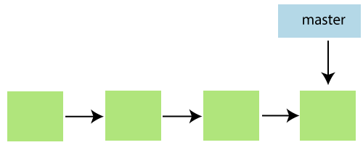
In most cases, the master is referred to as the main branch. Master branch is considered as the final view of the repo. Your local repository has its master branch that always up to date with the master of a remote repository.

Do not mess with the master. If you edited the master branch of a group project, your changes will affect everyone else and very quickly there will be merge conflicts.
Git Origin
In Git, The term origin is referred to the remote repository where you want to publish your commits. The default remote repository is called origin, although you can work with several remotes having a different name at the same time. It is said as an alias of the system.
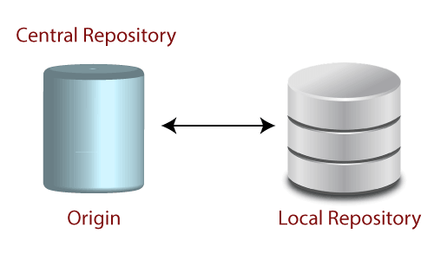
The origin is a short name for the remote repository that a project was initially being cloned. It is used in place of the original repository URL. Thus, it makes referencing much easier.

Origin is just a standard convention. Although it is significant to leave this convention untouched, you could ideally rename it without losing any functionality.
In the following example, the URL parameter acts as an origin to the "clone" command for the cloned local repository:
$ git clone https://github.com/ImDwivedi1/Git-Example
Some commands in which the term origin and master are widely used are as follows:
Git push origin master
Git pull origin master
Git has two types of branches called local and remote. To use git pull and git push, you have to tell your local branch that on which branch is going to operate. So, the term origin master is used to deal with a remote repository and master branch. The term push origin master is used to push the changes to the remote repository. The term pull origin master is used to access the repository from remote to local.
https://www.javatpoint.com/git-origin-master
Git Remote
In Git, the term remote is concerned with the remote repository. It is a shared repository that all team members use to exchange their changes. A remote repository is stored on a code hosting service like an internal server, GitHub, Subversion, and more. In the case of a local repository, a remote typically does not provide a file tree of the project's current state; as an alternative, it only consists of the .git versioning data.
The developers can perform many operations with the remote server. These operations can be a clone, fetch, push, pull, and more. Consider the below image:
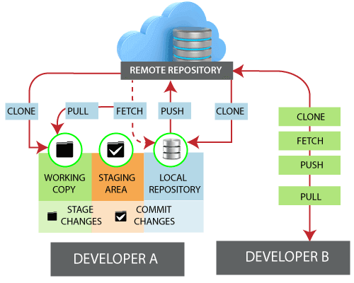
Check your Remote
To check the configuration of the remote server, run the git remote command. The git remote command allows accessing the connection between remote and local. If you want to see the original existence of your cloned repository, use the git remote command. It can be used as:
https://docs.github.com/en/github/getting-started-with-github/getting-started-with-git/managing-remote-repositories
git config --global user.name "your username"

git config --global user.password "your password"
git config --list
user.name=Your Name
user.email=youremail@yourdomain.com

git config --list
git remote -v
git remote remove origin
git branch –a
git config --global user.name rajeevpal
git config --global user.email rajeev.pal@bureauveritas.com

https://github.com/RajeevPal458/codingInterviewPreparation.git
Pass : Apr#1234 rajeevkumar.kp100@gmail.com
git branch --set-upstream-to=origin/<branch> master
git pull origin main

$ git remote
$ git remote -v:
Git remote supports a specific option -v to show the URLs that Git has stored as a short name. These short names are used during the reading and write operation. Here, -v stands for verbose. We can use --verbose in place of -v. It is used as:
Git Remote Add
When we fetch a repository implicitly, git adds a remote for the repository. Also, we can explicitly add a remote for a repository. We can add a remote as a shot nickname or short name. To add remote as a short name, follow the below command:
$ git remote add <short name><remote URL>
$ git remote rm <destination>
$ git remote –v
Git Remote Rename : $ git remote rename <old name><new name>
Git Show Remote
To see additional information about a particular remote, use the git remote command along with show sub-command. It is used as:
$ git remote show <remote>
Git Change Remote (Changing a Remote's URL) :-We can change the URL of a remote repository. The git remote set command is used to change the URL of the repository. It changes an existing remote repository URL.
Git Remote Set:
We can change the remote URL simply by using the git remote set command. Suppose we want to make a unique name for our project to specify it. Git allows us to do so. It is a simple process. To change the remote URL, use the below command:
$ git remote set-url <remote name><newURL>
The remote set-url command takes two types of arguments. The first one is <remote name >, it is your current server name for the repository. The second argument is <newURL>, it is your new URL name for the repository. The <new URL> should be in below format: https://github.com/URLChanged
https://www.javatpoint.com/git-remote
Git Tags
Tags make a point as a specific point in Git history. Tags are used to mark a commit stage as relevant. We can tag a commit for future reference. Primarily, it is used to mark a project's initial point like v1.1
Tags are much like branches, and they do not change once initiated. We can have any number of tags on a branch or different branches. The below figure demonstrates the tags on various branches.
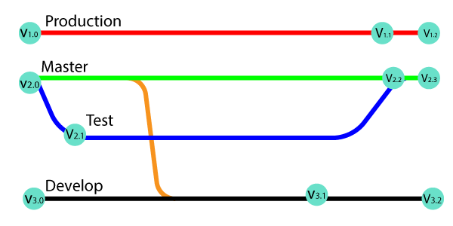
In the above image, there are many versions of a branch. All these versions are tags in the repository.
There are two types of tags.
- Annotated tag 2. Light-weighted tag
Both of these tags are similar, but they are different in case of the amount of Metadata stores.
When to create a Tag:
When you want to create a release point for a stable version of your code.
When you want to create a historical point that you can refer to reuse in the future.
Git Create tag
To create a tag first, checkout to the branch where you want to create a tag. To check out the branch, run the below command:
$ git checkout <Branch name>
Now, you are on your desired branch, say, master. Consider the below output:
Git Tags
You can create a tag by using the git tag command. Create a tag with some name say v1.0, v1.1, or any other name whatever you want. To create a tag, run the command as follows:
$ git tag <tag name>
The above command will mark the current status of the project. Consider the below example:
$ git tag projectv1.0
Git Tags :The above command will create a mark point on the master branch as projectv1.0.
Git List Tag :We can list the available tags in our repository. There are three options that are available to list the tags in the repository. They are as follows: git tag , git show , git tag -l ".*"
The "git tag":It is the most generally used option to list all the available tags from the repository. It is used as: $ git tag 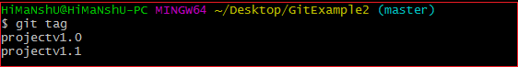
As we can see from the above output, the git tag command is listing the available tags from the repository.
https://www.javatpoint.com/git-tags

